# @begin OpenRefine_Workflow @desc Display one or more greetings to the user.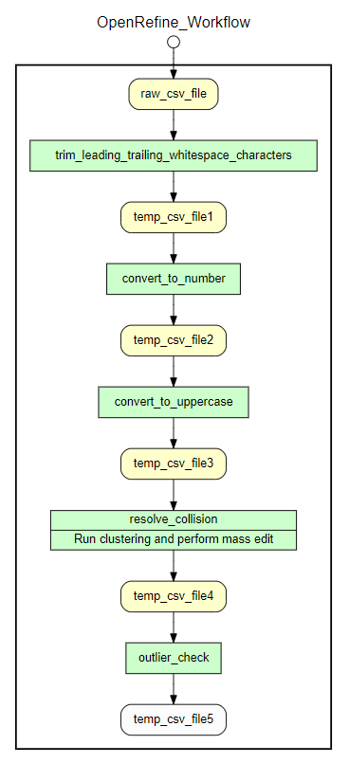

# @in raw_csv_file

# @begin trim_leading_trailing_whitespace_characters

# @in raw @as raw_csv_file

# @out pipe1out @as temp_csv_file1

# @end trim_leading_trailing_whitespace_characters

# @begin convert_to_number

# @in pipe1out @as temp_csv_file1

# @out pipe2out @as temp_csv_file2

# @end convert_to_number

# @begin convert_to_uppercase

# @in pipe2out @as temp_csv_file2

# @out pipe3out @as temp_csv_file3

# @end convert_to_uppercase

# @begin resolve_collision @desc Run clustering and perform mass edit

# @in pipe3out @as temp_csv_file3

# @out pipe4out @as temp_csv_file4

# @end resolve_collision

# @begin outlier_check

# @in pipe4out @as temp_csv_file4

# @out pipe5out @as temp_csv_file5

# @end outlier_check

# @end OpenRefine_Workflow

# @begin Complete_Workflow @desc Display one or more greetings to the user.

# @in raw_csv_file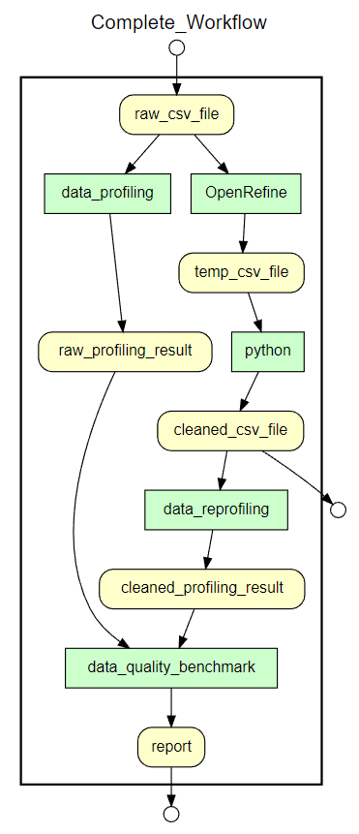

# @begin data_profiling

# @in raw @as raw_csv_file

# @out raw_profiling_result

# @end data_profiling

# @begin OpenRefine

# @in raw_csv_file

# @out temp_csv_file

# @end OpenRefine

# @begin python

# @in temp_csv_file

# @out cleaned_csv_file

# @end python

# @begin data_reprofiling

# @in cleaned_csv_file

# @out cleaned_profiling_result

# @end data_reprofiling

# @begin data_quality_benchmark

# @in cleaned_profiling_result

# @in raw_profiling_result

# @out report

# @end data_quality_benchmark

# @out report

# @out cleaned_csv_file

# @end Complete_Workflow

# @begin Data_Profiling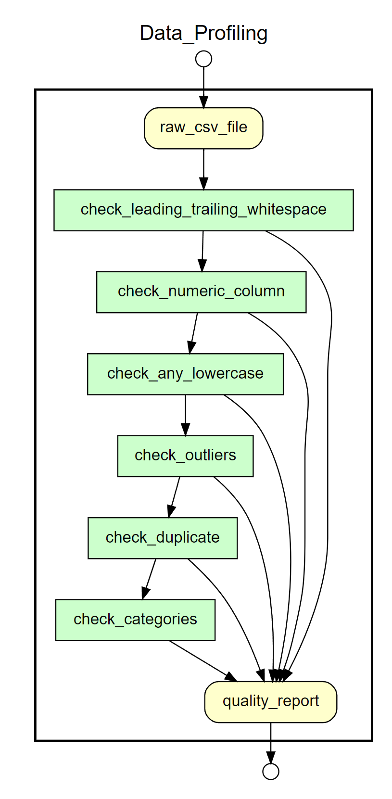

# @in raw_csv_file

# @begin check_leading_trailing_whitespace

# @in raw @as raw_csv_file

# @out quality_report

# @end check_leading_trailing_whitespace

# @begin check_numeric_column

# @in check_leading_trailing_whitespace

# @out quality_report

# @end check_numeric_column

# @begin check_any_lowercase

# @in check_numeric_column

# @out quality_report

# @end check_any_lowercase

# @begin check_outliers

# @in check_any_lowercase

# @out quality_report

# @end check_outliers

# @begin check_duplicate

# @in check_outliers

# @out quality_report

# @end check_duplicate

# @begin check_categories

# @in check_duplicate

# @out quality_report

# @end check_categories

# @out quality_report

# @end OpenRefine_Workflow

# @begin python_cleaning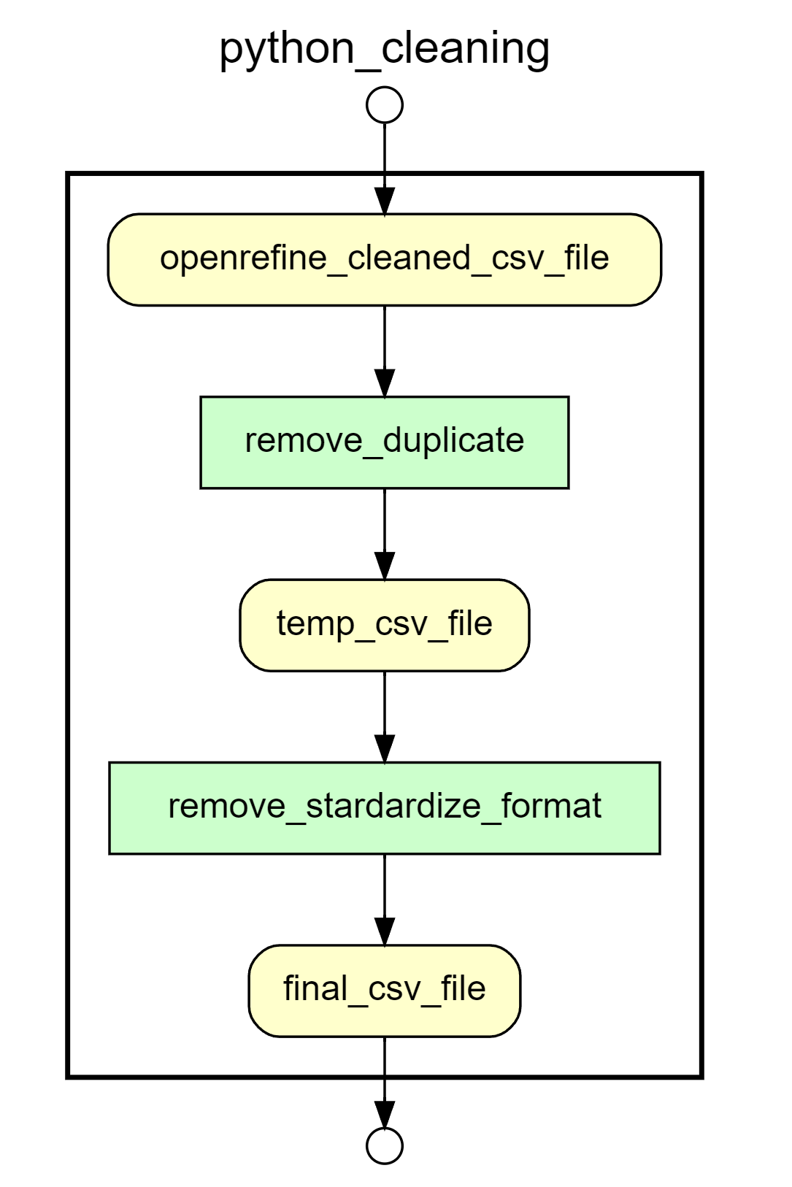

# @in openrefine_cleaned_csv_file

# @begin remove_duplicate

# @in openrefine_cleaned_csv_file

# @out pipe1out @as temp_csv_file

# @end remove_duplicate

# @begin remove_stardardize_format

# @in pipe1out @as temp_csv_file

# @out final_csv_file

# @end remove_stardardize_format

# @out final_csv_file

# @end OpenRefine_Workflow